LEAP – Curriculum Conversations: Handout

A Framework to Guide Curriculum
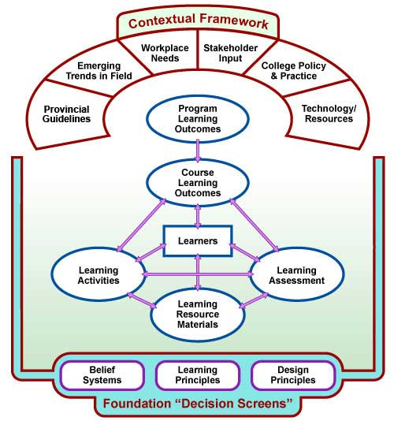

Key Principles:
- Design down, deliver up
- Learner in the centre of the process
- Outcomes are the drivers – content/resources considered last in process
- Alignment!

Resources:
Stakeholder input, mapping, published standards, data (KPI, surveys, etc.), external facilitator

Course Level Curriculum Review – Guiding Questions
Select one of your courses to work on.

1. What is the profile of the course?
- Is your course - stand alone, one of many within a program of study, co-requisite, pre-requisite for other courses, introductory, intermediate, advanced level?
- How does it relate to other courses?
- What courses does it build on?
- What courses follow it?

Comments/Analysis

2. How does your course align and map to the overall program outcomes?
- What credential is the program?
- Are the learning outcomes in your course aligned to a program of studies that has approved program standards from the Ministry of Training, Colleges and Universities or other professional or sectoral standards?
- Are the learning outcomes in your course written at the appropriate level of learning for the credential
- And for the laddering of learning over the sequence of the semester?
Comments/Analysis

3. How are the outcomes assessed in your course?
- What methods are you using?
- Are the assessment methods or practices aligned to one or more of the learning outcomes of the course?
Comments /Analysis

4. Have the outcomes in your course been validated?
- Has the course/program been through a curriculum renewal/mapping process to ensure the appropriateness and currency of the outcomes?
- Have the outcomes been validated or affirmed by employers/ advisory groups and professional bodies as relevant and important to the discipline/vocation?

Comments /Analysis

General Approaches to Developing Learning Outcomes:

Three approaches to starting to create or edit outcomes:

Theme approach
  - Identify themes related to intended curriculum
  - Consider verbs that best fit student expectations
  - Flesh out learning outcomes

Assessment approach
  - Identify “ideal” and “authentic” assessments
  - Describe the purpose of the assessments
  - Flesh out learning outcomes

Bundling approach
  - Used when many “micro” statements exist
  - Group or bundle related or like statements
  - Identify the most advanced taxonomy (verb) associated with the statements
  - Flesh out the learning outcomes

Difficult Situations

- Course ownership
- 1FT – many PT
- Historical Practice
- Demographics of program team

Strategies for Facilitating Change

- Pre-contemplators – establish the need, demonstrate benefits of engaging in curriculum work, externalize the message, separate the program from the people
- Bring in external facilitator if/when necessary
- Leverage PD opportunities such as Aligning and Building Curriculum (regional) or your own curriculum services
- Establish a blame-free culture
- Utilize positive, future design orientated change process models e.g. appreciative inquiry

